Commentary:
The recent global economic recession has generated many problems worldwide, such as increased unemployment, lack of consumer confidence and reductions in salaries and wages. In the United Kingdom, housing prices also plummeted, but during August the average cost for a home rose by 1.6%. This is, according to the article, mainly because of low interest rates and shortage of supply.
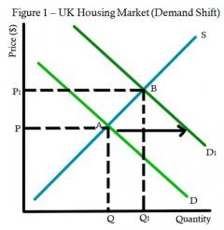
Low interest rates, the amount borrowers pay to lenders for the usage of the borrowed money, would result in a shift in demand, the ability and willingness to consume a commodity, to the right (Figure 1, D to D₁). This is because consumers are encouraged to borrow more, which would lead to increased spending. Consequently, the equilibrium would move from A to B, resulting in an increase in price (P to P₁).
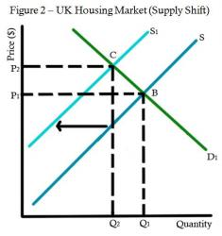
Furthermore, low interest rates would lead to lower mortgage repayments, hence allowing homeowners, usually predicted to sell their homes during a recession, to refrain from doing so. There would be a leftward shift in supply of homes (Figure 2, S to S₁), the ability and willingness to provide a commodity, as fewer owners choose to sell their houses, changing the equilibrium from B to C; the price would increase from P₁ to P₂. Overall, the change in price (P to P₂) would amount to 1.6%.
As mentioned in the article, it was forecasted that when there is a rise in interest rates in the future, the housing market may experience some falls in average price. This is because as interest rates increase, there is a higher tendency to save than spend. Thus, the demand curve shifts leftward (Figure 3, D to D₁). Also, homeowners may prefer to sell their houses because of higher mortgages, shifting the supply curve rightward (S to S₁). On the whole, the equilibrium would have changed from A to B, with prices falling from P to P₁.
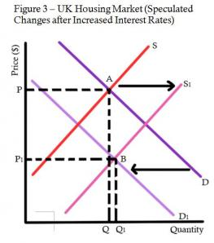
A future increase in interest rates may affect different stakeholders in various ways; demand and supply changes may not follow what is depicted in Figure 3. Those who have high mortgage repayments may sell their homes and seek to find smaller and cheaper housing. Consequently, demand for small homes may increase, while demand for larger homes may decrease.
The article presents the view that in the future, there may be further price falls. This is supported by the anticipation of higher interest rates. Also, because consumer confidence is at a low due to the global economic recession, once quantity supplied catches up with quantity demanded, ceteris paribus, it may be assumed that prices will not rise any further. Thus, fewer consumers would be able and willing to buy new homes and demand would drop, leading to a fall in housing prices.
However, other factors that affect demand and supply must be considered before that conclusion is made. For example in the USA, tax credit is available for homebuyers; this would increase disposable income, thus increasing demand. If this is also made available in the UK, the prices of houses may not necessarily fall. Also, because there is speculation that prices may rise, there may continue to be a shortage in supply as homeowners wait to take advantage of higher prices when they sell. Demand would also be enhanced by speculation as consumers are more willing to buy when prices are considered low, than in the future when prices may be higher. Some may also consider buying a house as an investment, because prices are predicted to rise. Thus, if these scenarios occur, price falls may not occur.
The article suggests the reasons why UK house prices rose by 1.6% and then speculates, with satisfactory reasons, why prices may fall in the future. In conclusion, the article is accurate in its justification, but does not consider the full array of alternative reasons which may affect the prices of homes.

