Commentary:
Recently, Credit Suisse conducted a survey and determined that Switzerland’s most expensive canton is Geneva, while the cheapest place to live is Appenzell Inner Rhodes, (AIR)
Demand is a curve showing the various amounts of a product consumers want and can purchase at different prices during a specific period of time. Supply is a curve showing the different amounts of a product suppliers are willing to provide at different prices. Equilibrium price and quantity are determined by the intersection of demand and supply. Price elasticity of demand (PED) indicates the responsiveness of consumers to a change in price, and is reflected in the relative slope of demand.
In the graph below, the markets for housing in Geneva and AIR are shown.
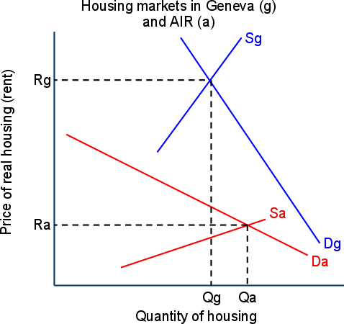

Demand for housing in Geneva (Dg), is high because of the many employment opportunities there. In addition, Geneva’s scarce land means supply of housing is low, resulting in a high equilibrium rent (Rg). Demand for housing in Geneva is inelastic, since renters in Geneva are less responsive to changes in rent compared to AIR, perhaps due to the perceived necessity of living close to their work.
Demand for housing in AIR (Da) is low, but supply is high due to the abundance of land. AIR is a rural canton with few jobs, therefore fewer people are willing and able to live there than in Geneva. Since living in the countryside is not a necessity, demand is relatively elastic, or responsive to changes in rent. The lower demand and greater supply make the AIR’s equilibrium rent relatively low.
The effect of a tax on property is a shift of the supply curve to the left and in increase in rents as landowners, forced to pay the canton a share of their rental incomes, raise the rent they charge residents.
In Geneva, property taxes are high, but this has little effect on the quantity demanded.
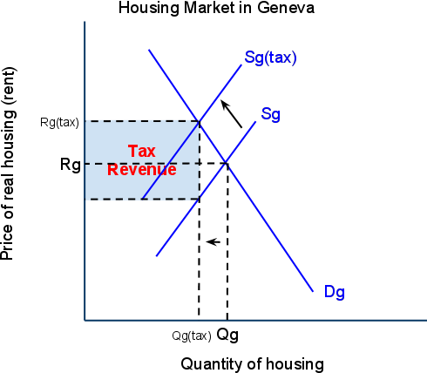
Geneva’s property tax shifts the supply of housing leftwards, as fewer landlords will be willing and able to supply properties to renters when the canton taxes rental incomes. However, the decrease in quantity demanded is proportionally smaller than the increase in the price caused by the tax, since demand for housing in Geneva is highly inelastic, or unresponsive to the higher price caused by the tax.
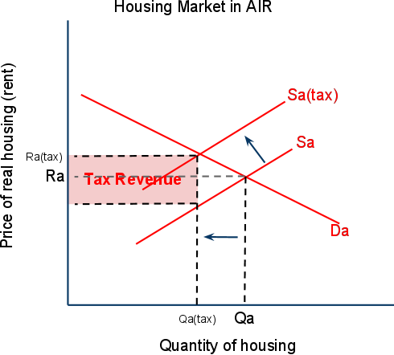
Renters in AIR are far more responsive to higher rents caused by property taxes, perhaps because living in AIR is not considered a necessity and there are more substitutes for rural cantons to live in. Renters in Geneva do not have the freedom to live in one of Switzerland’s many rural cantons, and are therefore less responsive to higher rents resulting from cantonal taxes.
A tax decrease in AIR could lead to a significant increase in the number of people willing to live there, since renters are highly responsive to lower taxes. To some extent, housing in AIR and Geneva are substitutes for one another. Lower taxes in AIR would make living there more attractive, and subsequently the demand for housing in Geneva would fall putting downward pressure on rents there. People would move to AIR, attracted by lower rents, and commute to work in the cities. According to the article, this is already happening:
“The disparity in the amount of disposable income… has increased the trend of people moving cantons for financial reasons... Economic necessities had led to an increase… of people moving address and opting to commute into work”.
There are many determinants of demand for housing in Switzerland, the primary one being location. High rents in Geneva are explained by the high demand for and the limited supply of housing. On the other hand, residents in AIR enjoy much lower rents, due to the weak demand and abundant land. Cantons should take into consideration the PED for housing when determining their property tax levels. Raising the tax Geneva will have little effect on rentals but could create substantial tax revenue. On the other hand, reducing taxes in AIR may attract many households away from the city to the countryside, drawn by the lower rents and property taxes.
Applying the basic principles of demand, supply and elasticity to Switzerland’s housing market allows households and government alike to make better decisions about where to live and how much to tax citizens.

